EE 97 Fall 2016

Thurs. 1330

Lab #5: Rectifier and Voltage Regulators

Sidarth Shahri

Partner: Christian Lopez

Station 10

Submitted 13 October 2016

Rectifier and Voltage Regulators

Experiment 1

Electricity provided by typical wall outlets in homes provide 120 AC volts. However, most devices require DC voltage for power. In order for AC voltage to be converted a much lower DC voltage, a transformer circuit is needed. AC voltage can be raised or lowered to needed values easily. An example of a transformer is shown below.

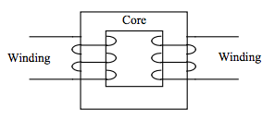

A transformer is made of two winding coils around an iron core. The AC voltage in one coil produces another AC voltage in the other coil. A ratio relates the number of coils to the voltage produced.

../../../../Screenshots/Screenshot%202016-10-13%2009.50.49.png

Vsec = Voltage in the secondary coil

Vpri = Voltage in the primary coil

Nsec = Number of coils in the secondary coil

Npri = Number of coils in the primary coil

A half-wave rectifier circuit can be used to convert AC current to DC current. The concept of the circuit lies in using a one-way diode to restrict the flow of AC current to only half the flow. This keeps the flow of current in one direction creating a DC current. The waveform will look like so:

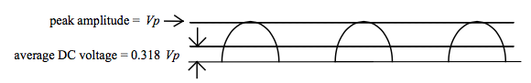

Notice the gaps. The gaps can be eliminated by using a filtering capacitor to create a more uniform DC current. The higher the capacity of the capacitor, the smaller the gaps will be. With the addition of the capacitor, the waveform will look like so:

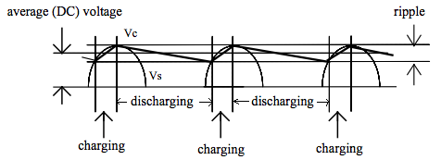

This waveform is called a ripple waveform and can be described by:

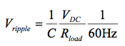

Measurements were made in ENG 249 Station 10 on October 6, 2016 using:

* 1 and 2kΩ resistors
* 1N4003 Diode
* 470 µF capacitor
* Tektronix DPO 3012 Oscilloscope
* Agilent Digital Multimeter 34405A (S/N: TW48090264)
* AC Adaptor (Class 2 Transformer) Model: 41A-9-500 (P/N: EPA090050-P5-SZ)
  + Input: AC 120V 60Hz 8W
  + Output: AC 9V 500mA
  + 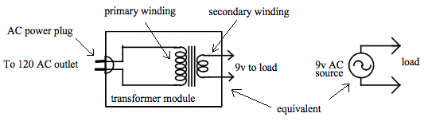

The schematic for the half-wave rectifier circuit is shown below:

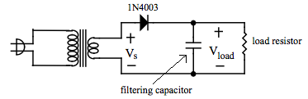

1kΩ

470 micro-Farad

Vprimary = 120V

Vsecondary = 11.13V

The winding ratio of the transformer is about 11/120.

The Digital Multimeter measured the capacitance of the 470µF capacitor to be 427µF.

Data is shown in the following table:

|  |  |  |  |  |  |
| --- | --- | --- | --- | --- | --- |
| RLoad  = 1kΩ |  | RLoad  = 2kΩ |  | RLoad  = 0Ω |  |
| Vave (scope) | 13.7 V | Vave (scope) | 14.3 V | Vave (scope) | 14.8 V |
| Vave (DMM) | 14.9 V | Vave (DMM) | 15.3 V | Vave (DMM) | 15.9 V |
|  | 2.75% |  | 1.42% |  | .9% |
| Vpp (scope) | 0.498 V | Vpp (scope) | 0.282 V | Vpp (scope) | 0.009 V |
| Vpp (DMM) | 0.47 V | Vpp (DMM) | 0.25 V | Vpp (DMM) | 0.0034 V |
|  | 3.6% |  | 9% |  | 15% |
| Vpp (calc) | 0.5432 V | Vpp (calc) | 0.220 V | Vpp (calc) | 0.000032 V |
| Frequency | 60 Hz | Frequency | 60 Hz | Frequency | 60 Hz |

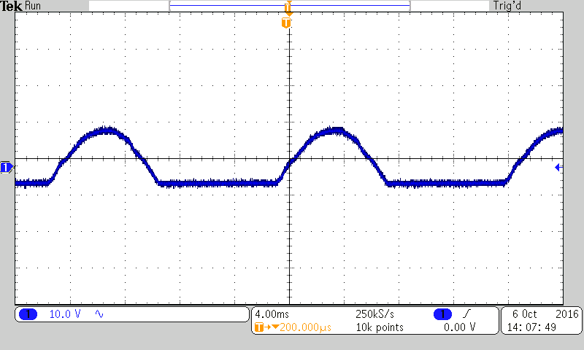

Half-Wave Rectified Waveform without Filtering Circuit

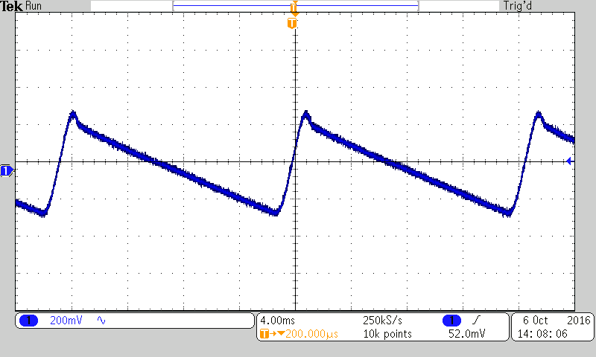

Half-Wave Rectified Circuit with Filtering Capacitor

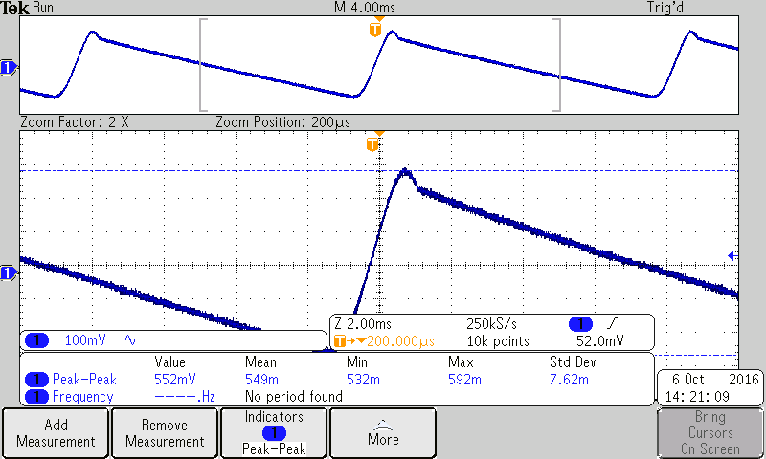

Data from Oscilloscope

The readings between the scope and the DMM for average DC voltage were pre5y similar. Our reading for the peak-to-peak voltage with the DMM and oscilloscope had a bigger gap between them but they were within reasonable range. With the DMM, we had to use an approximation of 2√2 x V rms. The DMM value and the oscilloscope value are related by Vrmsx2/sqrt(2) always. When we increased the load there was an increase in the voltage ripple.

**Experiment 2**

For this experiment, we built a full wave rectifier with IN4003 diodes and a 1kΩ resistor. We measured the average voltage for the full wave rectifier and compared it to the theoretical value. We also added a 470µF capacitor to help bridge the gaps in the waveform and create a more consistent DC current.

Measurements were made in ENG 249 Station 10 on October 6, 2016 using:

* 1kΩ resistor
* 4 1N4003 Diodes
* 470 µF capacitor
* Tektronix DPO 3012 Oscilloscope
* Agilent Digital Multimeter 34405A (S/N: TW48090264)

A schematic of the circuit is below:

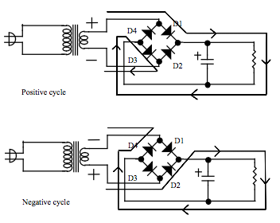

Here are the waveforms produced with and without the filtering capacitor:

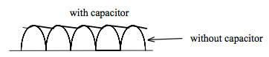

Ripple voltage was calculated with the following equation:

../../../../Screenshots/Screenshot%202016-10-13%2012.49.39.png

Data

|  |  |  |  |
| --- | --- | --- | --- |
| Without capacitor |  | With 430  Capacitor |  |
| Vave (scope) | 11 V | Vave (scope) | 15.2 V |
| Vave (DMM) | 1.5 V | Vave (DMM) | 14.6 V |
| Vave (calc) | 10.4 V |  | 5% |
|  | 1% | Vpp (scope) | 0.212 V |
| Vp (DMM) | 13.7 V | Vpp (DMM) | 0.25 V |
| Vp (scope) | 13.1 V | Vpp (calc) | 0.224 V |
|  | 4.8% |  | 5.2% |
| Frequency | 60 Hz | Frequency | 60 Hz |

We found that our values of the DMM and the scope were really close to one another. However the ripple of the full wave rectifier vs. the half wave was not exactly the same.